PRODUCTS FEATURES

Stadsing 3467
Automatic hand dryer, high-class stainless steel cover, with microcomputer inside, has strong anti-jamming, safe, simple to use and save energy. The inside high-speed professional motor can make the machine blow strong wind and dry hands in seconds. The fast heating element can make the wind warm even in cold environment.
The extra safe function is the two protection devices in the heating element and the machine will stop work automatically after 60 seconds continuously using.

TECHNICAL DATA
Rated Voltage: 230V~50Hz
Rated Power: 1800W
Wind Speed: >60m/s
Detective Distance: 10～120mm

INSTALLATION
Ⅰ. Position
Bathroom, lavatory and kitchen is suitable. Above ground beyond110cm. Keep away from the door to avoid bump.
Ⅱ. Method
1. Unscrew the two screws on the left and right of the cover (chart 1), then take out the cover (chart 2). After the machine is installed, pay attention to clench the cover carefully to avoid dropping the cover to the ground before unscrew the two screws again.
2.By chart 3 size, drilling 4 holes on the wall (diameter 6mm, depth 35mm) and bury with expansible tube and fix the machine with screws.
3. Put on the cover after the fixed board is installed, the air outlet on the fixed board and on the cover must be fixed each other very well. Pay attention to clench the cover carefully to avoid dropping the cover to the ground before install the cover to the fixed board.
4.The power cord can be fixed to the bottom of hand dryer, and it can be drilled through the bottom hold as well, then connect power. The position as the chart 4, A double color earth wire, B live wire (L), C neutral wire(N).

USAGE
The machine works automatically. After washing hands. put your hands to the bottom wind air outlet, the machine can blow strong wind automatically and dry hands immediately. The filter net need to be replaced or cleaned after long-time use.

CAUTION
1.The device should be installed on fixed, shock less wall.
2. Bumping to the device is forbidden.
3. Keep away from water like electric liquid.
4. Do not install in room with rusty air or electric dust.
5. Do not fix it by man who has no experience to avoid accidents.
6. Cut off the power when it is not used for long time..
7, Meaning of crossed-out wheeled dustbin:
Do not dispose of electrical appliances as unsorted municipal waste, use separate collection facilities.
Contact you local government for information regarding the collection systems available.
If electrical appliances are disposed of in landfills or dumps, hazardous substances can leak into the groundwater and get into the food chain, damaging your health and well-being.
When replacing old appliances with new ones, the retailer is legally obligated to take back your old appliance for disposals at least free of charge.
8,If the supply cord is damaged, it must replaced by the manufacturer, its service agent or similarly qualified persons in order to avoid a hazard.
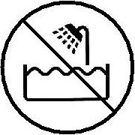
9, This hand dryer must be fixed out of reach of a person taking a bath or shower.
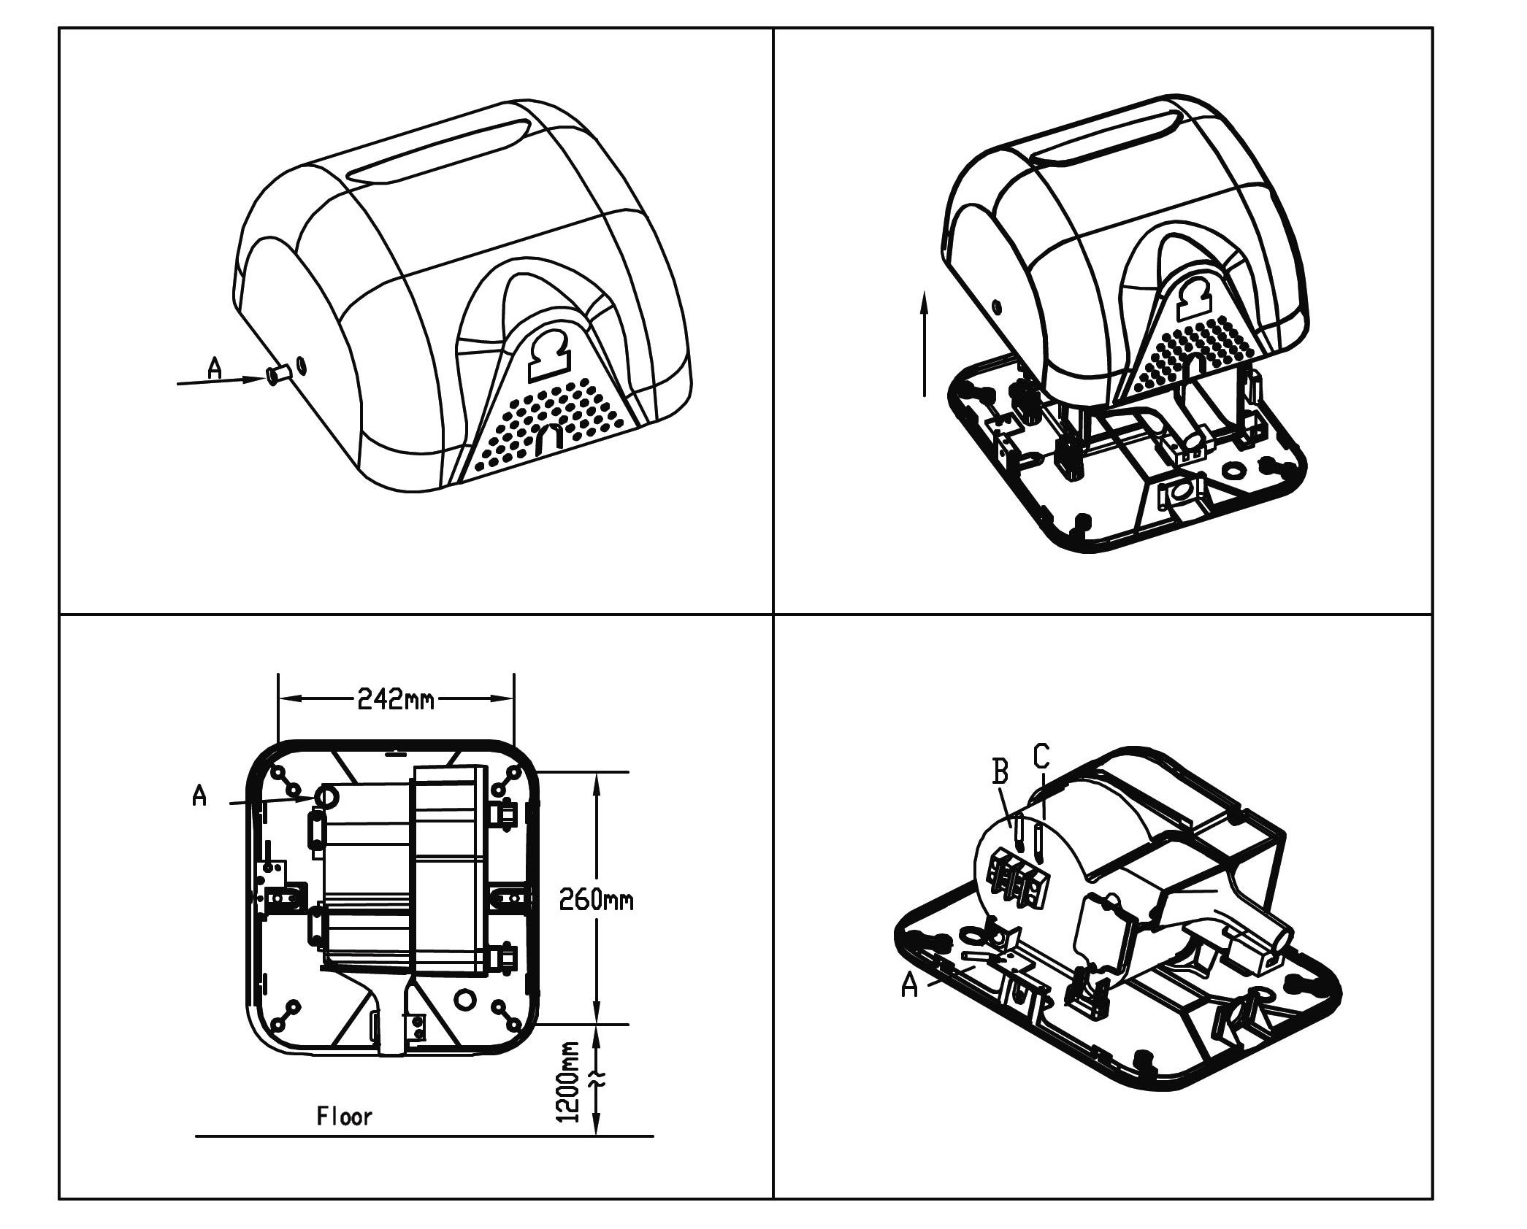
1 2

3 4

